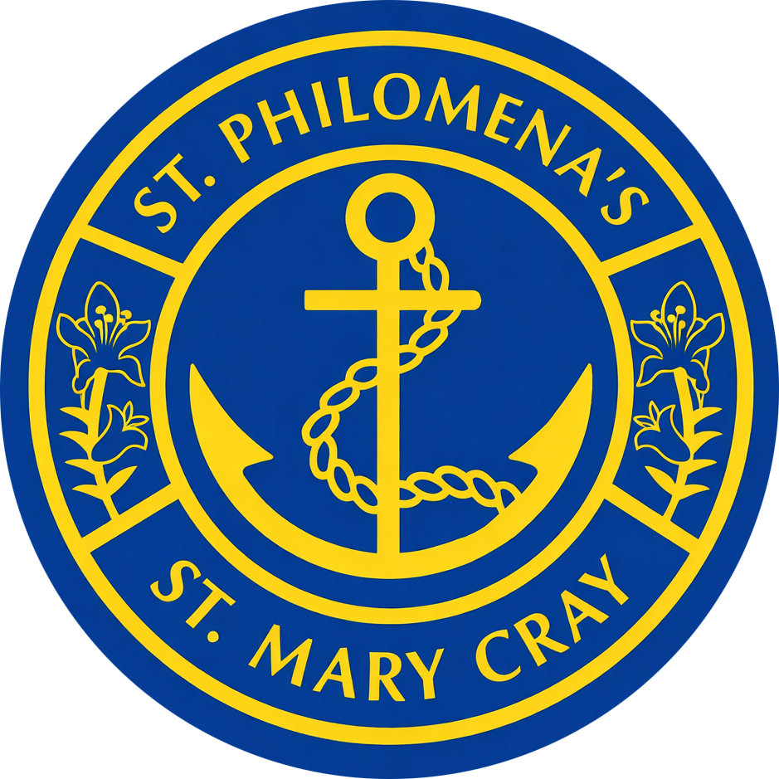

Our Class Saints

At St Philomena’s Catholic Primary School, each class has a special saint who accompanies and inspires the children throughout the year. These saints provide a wonderful example of faith, courage and love, reminding us that everyone is called to grow in holiness and follow God’s path.
Through learning about the lives of the saints, children discover how they used their gifts, trusted in God and lived out the teachings of Jesus. Their stories encourage us to reflect on our own choices and how we can share God’s love with those around us.
Our class saints also help us to explore the principles of Catholic Social Teaching, showing us how faith can be put into action through kindness, service, compassion and care for others. They remind us that even small acts of love can make a meaningful difference in our school and wider community.

Reception – St Francis of Assisi
Feast Day: 4 October
Patron Saint of Animals and Creation
St Francis of Assisi was chosen for our youngest children because he had a special love for God’s creation and all living things. He saw the beauty of God in nature and treated all creatures with kindness and care.
Catholic Social Teaching link:
St Francis is a wonderful example of Stewardship: Care for Creation, reminding us that the world is a precious gift from God and that we all have a responsibility to protect and care for it.

Year 1 – St Bernadette of Lourdes
Feast Day: 16 April
Patron Saint of the Sick
St Bernadette was chosen for Year 1 because she showed great humility, faith and compassion. Through her experiences at Lourdes, she became a symbol of hope and healing for people throughout the world.
Catholic Social Teaching link:
St Bernadette inspires us to live out Human Dignity and the Preferential Option for the Poor and Vulnerable by showing compassion, kindness and care for those who are sick or suffering.

Year 2 – St Joseph
Feast Day: 19 March
Patron Saint of Workers and Families
St Joseph was chosen for Year 2 because he was a loving and faithful man who cared for Jesus and Mary. Through his work as a carpenter, he showed the value of responsibility, dedication and service.
Catholic Social Teaching link:
St Joseph reflects The Common Good and Participation, teaching us that everyone has gifts to share and an important role to play in building a caring community.

Year 3 – St Anthony of Padua
Feast Day: 13 June
Patron Saint of Lost Things
St Anthony was chosen for Year 3 because he was a great teacher who used his knowledge and faith to help others. He dedicated his life to sharing God’s message and guiding people towards Christ.
Catholic Social Teaching link:
St Anthony demonstrates Participation and Solidarity, showing us that we are called to use our talents and knowledge to support and serve others.

Year 4 – St Thomas More
Feast Day: 22 June
Patron Saint of Teachers, Lawyers and Public Servants
St Thomas More was chosen for Year 4 because he was a man of courage, wisdom and integrity. He remained faithful to his beliefs and stood up for truth and justice.
Catholic Social Teaching link:
St Thomas More inspires us to live out Promoting Peace and Distributive Justice by standing up for what is right and working towards a fairer world.

Year 5 – St Paul the Apostle
Feast Day: 29 June
Patron Saint of the Church and Mission
St Paul was chosen for Year 5 because his life shows the power of transformation and the importance of sharing the Good News. He travelled widely to spread the message of Jesus and build Christian communities.
Catholic Social Teaching link:
St Paul encourages us to live out Solidarity, reminding us that we are one global family called to share God’s love with others.

Year 6 – St Joan of Arc
Feast Day: 30 May
Patron Saint of Courage and Young People
St Joan of Arc was chosen for Year 6 because she showed great courage, faith and determination from a young age. She trusted in God and used her voice to bring about change.
Catholic Social Teaching link:
St Joan of Arc reflects Participation and Human Dignity, reminding us that every person has a voice, unique gifts and the ability to make a difference.

Living as a Community of Saints
Our class saints remind us that we are all called to follow Jesus and live lives of love and service. Through their examples, our children are encouraged to put Catholic Social Teaching into action and become compassionate, courageous and faithful members of our school and wider community.

