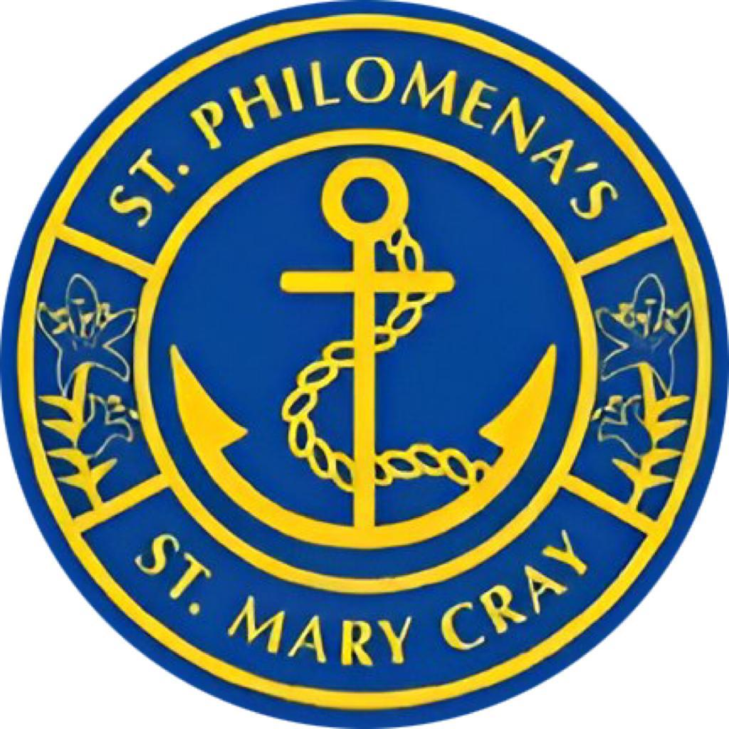

Serving Our Community Through Charity and Action
At St Philomena’s Catholic Primary School, our mission calls us to serve our community by following the example of Jesus through love, compassion and generosity. We believe that faith is lived out through action, and that every member of our school community has a part to play in caring for others.
Our approach to charity is rooted in the principles of Catholic Social Teaching. We encourage our children to recognise the dignity of every person, show compassion towards those in need and understand that service is not only about giving money. Charity is also expressed through kindness, sharing, prayer, time, friendship and practical support.
We are mindful of the many requests placed upon families and our wider community, and we aim to support charitable causes in a thoughtful and meaningful way. Our focus is on helping children understand why we give, who we are supporting and how even small acts of love can make a difference.
Throughout the year, our school community supports a range of charities and causes. Our Lenten Walk raises money for the Catholic Children’s Society, helping children to understand the importance of supporting others facing difficult circumstances. Through our pre-loved uniform initiative, we support families within our own school community while promoting sustainability and care for creation.
We take part in community and national events such as the Greenwich Mini Marathon, raising funds for a local hospice, Children in Need, the Poppy Appeal and our Christmas charity jumper day. These opportunities help children see that they are connected to a wider community and can make a positive difference beyond our school.
We are proud to support CAFOD and to help children develop a sense of global responsibility by learning about the lives of people around the world. Our Harvest collection allows us to share our blessings with local food banks, supporting those in our local area who may need additional help.
Our service also extends to acts of kindness that do not involve fundraising. Following our Crowning of Mary celebration, children share flowers with residents in local care homes, bringing joy and building relationships with members of our wider community. Children also take part in prayer, environmental projects and everyday acts of kindness that reflect Jesus’ call to love and serve others.
Through all of these experiences, our children learn that they have the ability to make a difference. At St Philomena’s, we strive to nurture hearts that are generous, compassionate and ready to serve — living out our mission by caring for one another and our wider community.

