To paste to website:
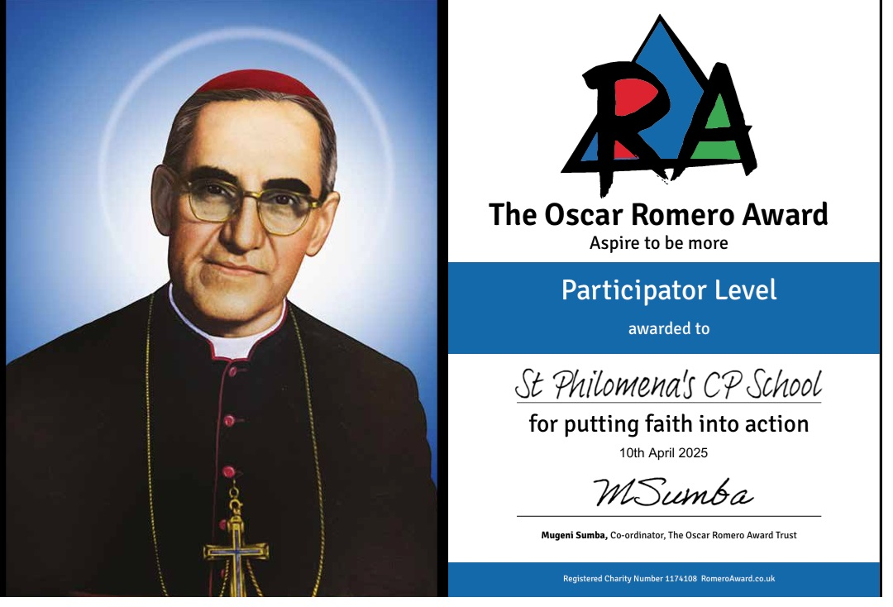

Oscar Romero Award
At St Philomena's Catholic Primary School, we are proud to be a Participator School in the Oscar Romero Award. This recognises our commitment to living out Catholic Social Teaching through prayer, learning and action, following the example of Archbishop Oscar Romero, who dedicated his life to standing up for justice, peace and the dignity of every person.
The Oscar Romero Award encourages our whole school community to place Gospel values at the heart of everything we do. Through acts of service, charitable outreach, care for creation and a commitment to social justice, our pupils learn that faith is something to be lived each day.
Building on this achievement, we have now submitted our evidence for the Developer Award. This reflects our continued commitment to embedding Catholic Social Teaching across our curriculum and school life, empowering our pupils to become compassionate, courageous and active citizens who work for the common good.

